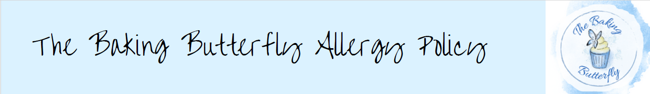

This policy demonstrates our commitment to reducing the risk to staff, visitors and customers

concerning food provision and production, which could cause allergic reactions.

Through this policy, we will aim to minimise the risk of allergens causing harm through safe

procedures, staff training and planning for effective responses to allergenic emergencies.

All food businesses must identify and declare if any of these ingredients are used in any of the

products being made within this business. The Baking Butterfly is committed to ensuring all ingredients for every menu item are accurately listed, with any of the 14 food allergens shown above, being highlighted.

We also commit that every item that is purchased from a market stall/counter and taken away for

consumption will be fitted with a label detailing the ingredients and any allergens

contained therein, as a commitment to best practice.

People can be allergic to any ingredient, so it is best practice to know all the ingredients in any food item, but the ones shown above MUST be declared.

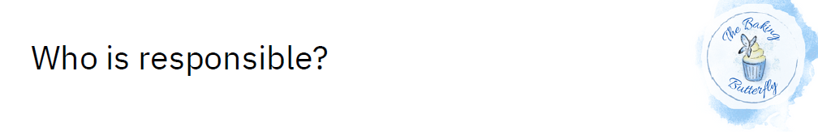

The business owner at The Baking Butterfly is responsible for creating this Allergen Policy and ensuring all documentation regarding ingredients, allergens, and staff information sheets are accurate and updated.

The business owner is responsible for ensuring all procedures are adhered to on shift and that all

staff receive training, including annual refresher training on safe food handling, including allergen

awareness. In addition, the business owner is responsible for ensuring a qualified first aider is always on site.

All staff, regardless of their position, are responsible for keeping the food hypersensitive customer safe. Everyone must understand the procedures in place to protect them and follow all the guidelines carefully.

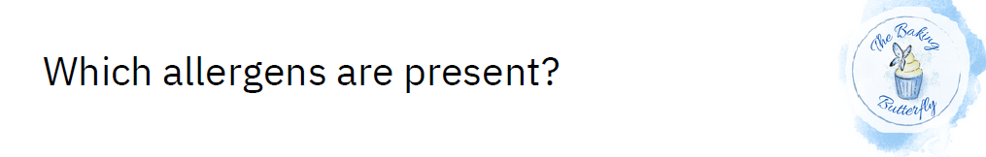The Baking Butterfly will take account of all ingredients used in a food item, including hidden allergens. For example:

* Celery refers to the stalks, leaves and seeds of both celery and celeriac, including celery salt.
* Cereals containing gluten include bread, pasta, pastry, cakes, royal icing, sauces, soups and batter.
* Crustaceans include lobster, prawns, crab, scampi and pastes made with these.
* Eggs can be found in pasta, quiche, sauces, cakes, mousses and mayonnaise, or items may be brushed with an egg glaze.
* Fish can be found in salad dressings, on pizza and in Worcestershire sauce.
* Lupin flour and seeds are used in some pastries and bread and often in products labelled as gluten free.
* Molluscs include squid, snails, mussels and oysters, including oyster sauce.
* Milk can be found in cheese, butter, cream and yoghurt. Items may also be brushed with a milk glaze or contain milk powder.
* Mustard refers to seeds, powder and liquid mustard and is often found in dressings and marinades, sauces, curries and soups. Cress also contains the substance which causes a reaction to mustard.
* Nuts, such as almonds, Brazil nuts, hazelnuts, pecans, pistachios and cashews, macadamia and walnuts, are commonly used in desserts, bread, ice cream and sauces, whether whole, ground or as an oil.
* Peanuts, including peanut flour (groundnuts) and groundnut oil, can be found in desserts, cakes and sauces.
* Sesame seeds and sesame oil are often found in bread, hummus, tahini and stir-fried dishes.
* Soya refers to soya protein, flour and beans and can be found in tofu, sauces, edamame beans, desserts and many vegetarian and vegan products.
* Sulphur dioxide and sulphites are preservatives commonly found in dried fruit, fruit juice, meat products, wine and beer. (Concentrations of more than 10mg/kg or 10mg/litre)

Any changes to suppliers or to the product or ingredient that is delivered to the business MUST be checked and updated with the latest information. Similarly, any recipe changes must be checked and updated in the information sheets and the allergen matrix. Any new products must receive the same checks and sharing of information.

Giving information to customers

At The Baking Butterfly we encourage best practice, so we ask for allergen information when you place an order and include allergen information on your product box and on our website.

Any customers who require further information are welcome to speak directly with The Baking Butterfly or make an enquiry through the website. More details can be found under ingredients section on the website.

Good kitchen procedures

The following lists the procedure we have in place to minimise the risk of allergenic cross contamination in the kitchen and how we reduce risk to staff, visitors and customers.

These procedures are based on the outcomes of a thorough HACCP plan and Allergen

risk assessment.

* All ingredients will come from reputable suppliers. Any changes in suppliers will be detailed, and full traceability records shall be kept.
* When allergenic ingredients are kept in-house, they shall be stored separately and in sealed
* containers on lower shelves.
* Thoroughly clean food preparation surfaces using the two-stage cleaning technique after using
* allergenic ingredients.
* Carefully clean up any spillages of allergenic ingredients as soon as they occur. Use a single-use cloth, not a reusable one.
* Ensure that food handling equipment, such as mixers, blenders, processors and weighing scales, is cleaned thoroughly before using it for an allergen-free product.
* When cleaning food handling equipment, dismantle it carefully to ensure all parts are cleaned and no allergenic residue, such as powders and seeds, is left in hard-to-reach places.
* Use designated, colour-coded cleaning equipment to clean areas where allergen-free foods
* are prepared.
* Only use the same utensils for allergenic and allergen-free foods after thoroughly cleaning them in between uses.
* Staff must wash their hands properly using the correct technique before and after handling
* allergenic ingredients and food products.

What to do in an emergency situation

An emergency situation is unlikely due to the nature of the business as most items are collected or delivered and consumed off site. In the event of an emergency the following procedures will be followed:

Staff have had basic first aid training and will assist in an emergency situation. Basic first aid training is refreshed annually.

If a customer is having a severe allergic reaction:

* Ensure the casualty is comfortable, ideally lying down or sitting in a chair. If breathing is difficult, assist them in lying down, and raise their legs.
* If the person has an auto-injector, such as an EpiPen, Jext Pen or Emerade Pen, ask them to locate and use it. The casualty might be able to inject themselves, otherwise, you can assist them if you know how.
* Call 999 for an ambulance as soon as possible and explain that the person is having a severe allergic reaction, mentioning anaphylaxis specifically.
* If there’s no improvement after five to 10 minutes, use the second auto-injector if a second dose is available. Ensure this is in the opposite leg this time.
* Reassure the person and do your best to keep them calm.

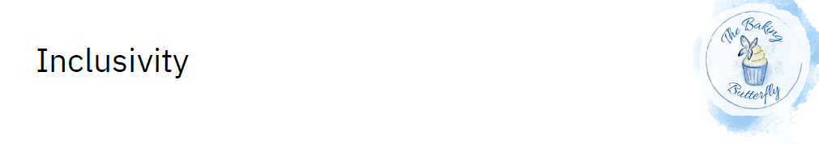

In order to ensure that food hypersensitive customers can choose from a range of options, a

conscious effort is made to reduce the number of allergens used and to avoid unnecessary use of

allergens. Careful procedures to prevent cross-contamination reduce the need for precautionary

allergen labelling, providing more options for the food hypersensitive customer.